34.101: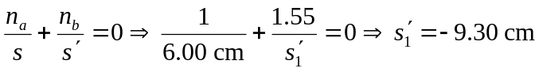
So the image is 8.26 cm below the top glass surface, or 1.24 cm above the page.

